

|  |
| --- |
| E-BUS MANAGEMENT  2018 |
|  |
| September 7  Authored by: D. CHARAN SAI |



# ABSTRACT :

# The E-Bus Management Based on Current Location System is an innovative solution designed to enhance the efficiency and reliability of public transportation by providing real-time bus tracking and booking capabilities. This system is part of an intelligent transportation framework aimed at predicting bus arrival times based on the current location and dwell time at previous stops. The core objective of this project is to reduce passenger waiting times, improve the accuracy of bus arrival predictions, and increase overall ridership satisfaction. By leveraging GPS data and user inputs, the system enables passengers to track buses in real-time, search for buses based on their source and destination.

# The system consists of three primary modules:

# Admin, Driver/Travel Agencies, and Users. The Admin module allows administrators to create accounts for bus drivers and travel agencies and manage the overall operations. The Driver/Travel module enables drivers and agencies to update and post complete bus details, including bus type, routes, and contact information.

# INTRODUCTION :

# Public transportation plays a vital role in modern urban life, offering an affordable and efficient means of travel for millions of people. However, the reliability and efficiency of public transport systems, particularly bus services, can be hampered by various factors such as traffic congestion, unpredictable delays, and inaccurate arrival times. Passengers often face uncertainty regarding bus schedules, leading to increased waiting times and dissatisfaction. The E-Bus Management System based on real-time location is a comprehensive solution aimed at addressing these issues by utilizing modern technology to predict bus arrival times and improve overall passenger experience.

# The system architecture is built using ****HTML****, ****CSS****, ****JavaScript****, and ****Firebase Firestore**** for seamless integration between the front end and back end. ****Firebase**** serves as the primary database, enabling real-time data updates and synchronization. The bus details, including bus number, source, destination, and current location, are stored in the Firestore database, providing real-time data for all system users. Additionally, the system is optimized for various devices and screen sizes, ensuring a smooth experience across desktops, tablets, and mobile phones.

# REQUIREMENTS ANALYSIS :

#### 1. ****Functional Requirements :****

##### 1.1 ****User Authentication and Authorization****

* **Login/Registration**: Users, drivers, and admins should be able to create accounts using email and password.
* **Admin Dashboard**: Admins can manage user and driver profiles, configure settings, and oversee system operations.
* **Role-Based Access Control (RBAC)**: Access to different modules is restricted based on user roles (Admin, Driver, Passenger).

##### ****1.2 Bus and Route Management****

* **Add/Update Bus Details**: Drivers and travel agencies can post and edit bus information, including bus number, type, route, driver details, and contact information.
* **Assign Routes**: Drivers can assign specific routes to buses, which passengers can view while searching for available transport.

##### 1.3 ****Bus Search Functionality****

* **Location-Based Search**: Users can search for buses based on their current location.
* **Filters**: Passengers can filter buses based on bus type (AC/Non-AC), departure time, and availability.

#### 2 . ****Non-Functional Requirements****

##### 2.1 ****Performance****

* **Scalability**: The system must support high user traffic and scale seamlessly as the number of users grows.
* **Response Time**: The system must display real-time bus locations and arrival times within seconds of receiving the location data.

##### 2.2 ****Security****

* **Data Encryption**: Sensitive data, such as passwords and personal information, should be encrypted in transit and at rest.
* **User Authentication**: Implement secure login mechanisms, including password encryption and two-factor authentication (if necessary).
* **Data Access Control**: Role-based access controls should ensure that only authorized users can access sensitive information.

##### 2.3 ****Usability****

* **Responsive Design**: The system interface should be accessible and fully functional across various devices (desktop, mobile, tablet).
* **User-Friendly Interface**: The system should have an intuitive, easy-to-navigate UI for passengers, drivers, and admin users.

##### 2.4 ****Reliability****

* **Availability**: The system should be available 24/7 with minimal downtime.
* **Error Handling**: Implement error handling to manage system crashes, invalid inputs, and failed operations smoothly.

##### 2.5 ****Maintainability****

* **Modular Design**: The system should be developed using a modular approach to simplify updates, bug fixes, and future enhancements.

#### ****4. System Architecture :****

The system follows a **3-tier architecture**:

1. **Client-side (Frontend)**:
   * HTML, CSS, JavaScript for rendering UI.
   * Firebase Authentication for user sessions.
   * AJAX for making async requests to fetch and update data.
   * Input validation using client-side JavaScript.
2. **Backend (Business Logic & Data Management)**:
   * **Firebase** is used as the backend for storing and managing the bus details and user data.
   * **Firestore** is the NoSQL database used for real-time data storage (bus data, user profiles).
   * **Node.js/Express** (optional) can be used for server-side logic if you need advanced functionality like handling API routes.
3. **Database (Data Storage)**:
   * **Firebase Firestore** for storing bus details (source, destination, location), user details, bookings, etc.
   * **Real-time Database** could be added for live bus tracking and pushing location updates.

#### ****5. Database Design :****

**Collections**:

* **Users**:
  + userId (string): Unique ID.
  + email (string): User email.
  + role (string): "Admin", "Driver", "User".
  + createdAt (timestamp): Registration date.
* **Buses**:
  + busId (string): Unique bus ID.
  + busNumber (string): Unique bus number.
  + source (string): Starting point (case-insensitive search).
  + destination (string): Endpoint.
  + location (geo-point): Current GPS location.
  + time (timestamp): Time of the next stop.
  + type (string): Bus type (AC/Non-AC, Sleeper, etc.).

#### ****6. Deployment & Hosting :****

* **Frontend Deployment**:
  + Host the static frontend (HTML, CSS, JavaScript) on **Firebase Hosting** or **GitHub Pages**.
* **Backend Deployment**:
  + Utilize **Firebase Functions** for handling dynamic backend logic (optional, for additional flexibility).
  + Alternatively, deploy a **Node.js** server using **Google Cloud Platform (GCP)** or **AWS** for more complex backends.
* **Database Hosting**:
  + Use **Firebase Firestore** for real-time NoSQL database.
  + Leverage **Firebase Realtime Database** for live bus location tracking if needed.

#### ****7.SOURCE CODE:****

* **GITHUB REPOSITORY LINK** :

[**Imcharan17/E-Bus-managment (github.com)**](https://github.com/Imcharan17/E-Bus-managment)

* **WEBSITE LINK** :

[**https://imcharan17.github.io/E-Bus-managment/**](https://imcharan17.github.io/E-Bus-managment/)

#### ****7 . SCREENSHOTS &EXPLANATION:****

#### ****7.1 HOME PAGE:****

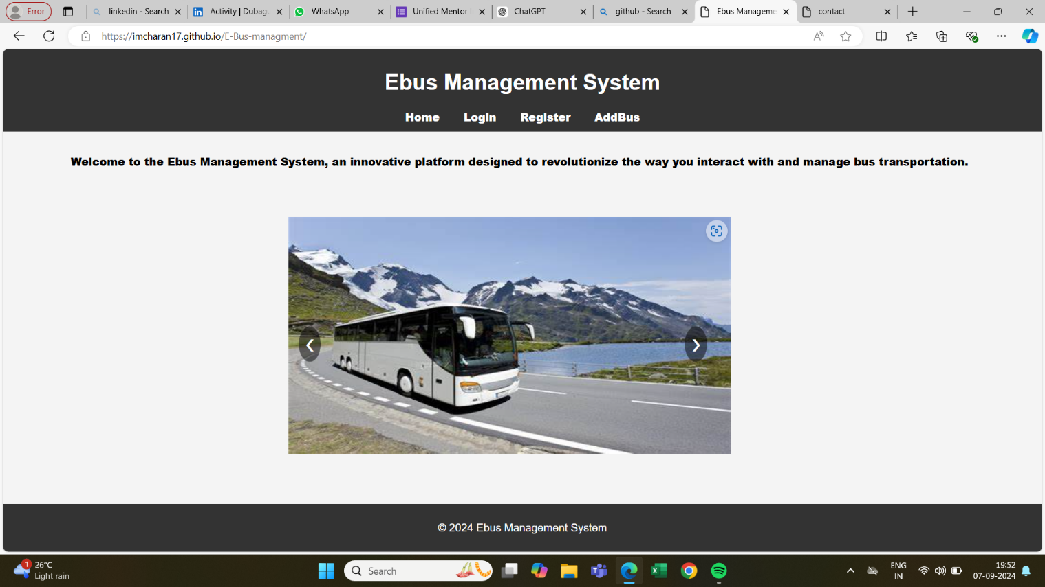

Header Section:

* The title "Ebus Management System" is prominently displayed at the top.
* A navigation bar includes links to different sections: "Home," "Login," "Register," and "AddBus."

Main Section:

* The main content features a welcoming message: *"Welcome to the Ebus Management System, an innovative platform designed to revolutionize the way you interact with and manage bus transportation."*
* Below the text, there is an image carousel that shows a large picture of a bus on a scenic road, surrounded by mountains and water. The image appears to be part of the system's design to visually represent bus travel and transportation.

Footer Section:

* Footer contains the text: "© 2024 Ebus Management System".

#### ****7.2 LOGIN PAGE:****

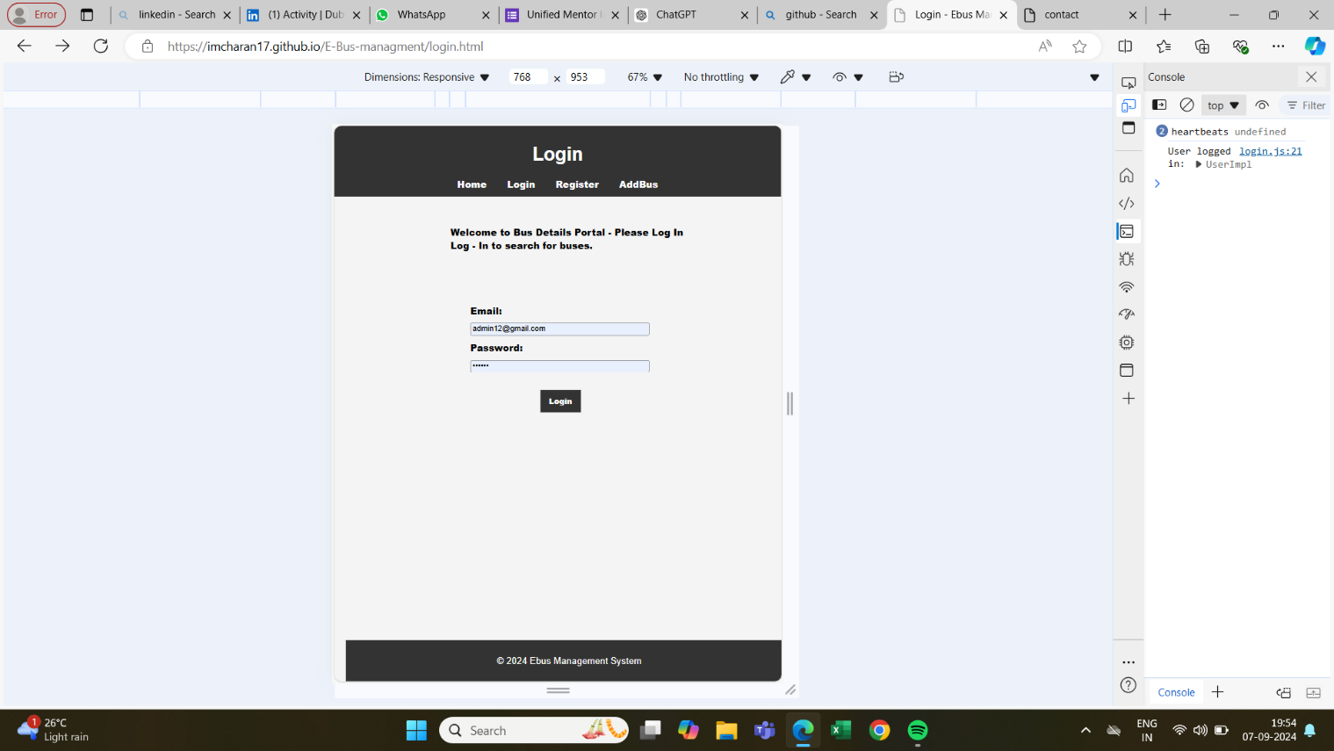

Header Section:

* The page title "Login" is prominently displayed at the top.
* The navigation bar contains links for "Home," "Login," "Register," and "AddBus."

Main Content:

* A message at the top reads: *"Welcome to Bus Details Portal - Please Log In. Log - In to search for buses."* This indicates that users must log in to access the bus search and other functionalities.
* There are two input fields below the message:
  + Email: A placeholder text shows an example email (admin12@gmail.com).
  + Password: The field is obscured as expected for password input.
* A Login button is centered below the fields to submit the login information.

Footer Section:

* At the bottom, the footer displays: "© 2024 Ebus Management System", indicating the copyright year and the system name.

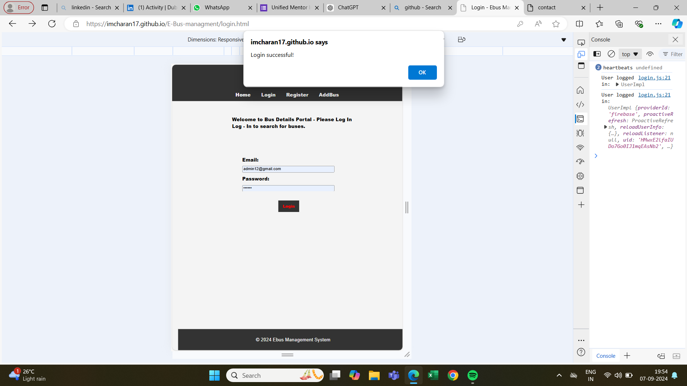

* Above image shows that alter after successful login by verifying credentials.
* At right side console region we can see that no error.
* We can also understand that the above website is also responsive too.

#### 

#### ****7.3 SEARCH BUS:****

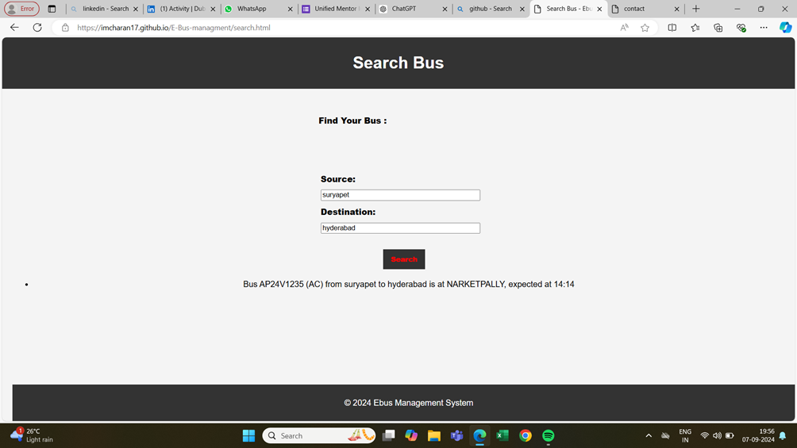

This search bus functionality will be accessed after successful login

only .Such that unregistered user cant access the information.

Header Section:

* The page title "SEARCHBUS" is prominently displayed at the top.
* The navigation bar contains links for "Home," "Login," "Register," and "AddBus."

Main Content:

There are two input fields below the message:

* + Source: A placeholder text shows a source to get the information of bus . For Example : Suryapet .
  + Destination: The field is obscured as expected for destination input. For Example : Hyderabad .
* A search button is centered below the fields to search the bus information.
* As the result we got the information of bus .

Footer Section:

At the bottom, the footer displays: "© 2024 Ebus Management System

****7.4 SEARCH BUS:****

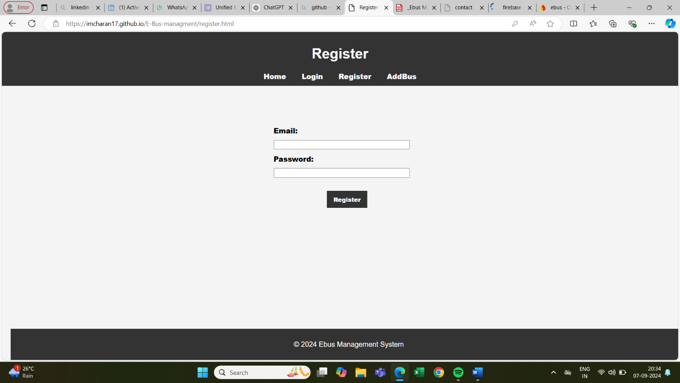

Header Section:

* The page title "Register" is prominently displayed at the top.
* The navigation bar contains links for "Home," "Login," "Register," and "AddBus."

Main Content:

* There are two input fields below the message:
  + Email: A placeholder text shows an example email (admin12@gmail.com).
  + Password: The field is obscured as expected for password input.
* A Register button is centered below the fields to submit the login information.

Footer Section:

* At the bottom, the footer displays: "© 2024 Ebus Management System", indicating the copyright year and the system name.

### 8. Conclusion :

The **E-Bus Management System** represents a significant advancement in public transportation management, aiming to address common inefficiencies and enhance the overall user experience for passengers and transport providers alike. By integrating real-time GPS tracking, accurate bus arrival predictions, and a streamlined ticket booking process, the system provides a comprehensive solution to modernize bus management and improve operational efficiency.

Through rigorous requirements analysis, we have defined the essential functional and non-functional requirements that ensure the system meets the needs of its diverse stakeholders. The implementation of a role-based access control mechanism, real-time data updates, and a user-friendly interface ensures that the system remains secure, scalable, and easy to use. Additionally, the modular design approach promotes maintainability and future-proofing, allowing for seamless updates and enhancements.

The system’s architecture, built on a robust backend with Firebase and a responsive frontend interface, provides a reliable and efficient platform for managing bus operations. Real-time tracking and predictive features will significantly reduce passenger wait times, enhance the accuracy of bus schedules, and improve overall satisfaction.

In summary, the **E-Bus Management System** is poised to revolutionize public transport management by leveraging cutting-edge technology to deliver a user-centric, efficient, and scalable solution. As the system moves into the development phase, it is expected to fulfill its objectives of enhancing transport efficiency, improving passenger experiences, and providing valuable tools for transport providers to manage their operations effectively.